

|  |  |
| --- | --- |
| **SCHOOL DISTRICT/LOCAL CONTACT NUMBER:** |  |

|  |  |  |  |  |  |  |
| --- | --- | --- | --- | --- | --- | --- |
| **Physician/Licensed Practitioner*:** | | | |  | | |
| **Address:** |  | | | | | |
| **Student Name:** | | |  | | | |
| **DOB** | |  | |  | **IEP Date:** |  |

|  |  |
| --- | --- |
| Dear: |  |

In accordance with Michigan’s School Based Medicaid procedures, we are seeking your assistance in determining the health care needs of the student listed above relative to his/her personal care needs as referenced in his/her Individualized Educational Plan (IEP). The checked list below indicates the personal care services we feel are necessary to provide throughout the school day.

|  |
| --- |
| **Personal Care Script** |

Please review the list below. If you are in agreement with our instructional aides providing these services for the above named student, please sign & date below and return this form to:

|  |  |
| --- | --- |
| ☐ Eating/Feeding | ☐ Meal Preparation |
| ☐ Grooming | ☐ Bathing |
| ☐ Ambulation | ☐ Assistance with self-administered medication |
| ☐ Mobility/Positioning | ☐ Toileting |
| ☐ Muscle Strengthening | ☐ Transferring |
| ☐ Medical Equipment Maintenance | ☐ Personal Hygiene |
| ☐ Health Related Functions through hands on Assistance, supervision and Cueing | ☐ Maintaining Continence |
|  | ☐ Skin Care |
| ☐ Respiratory Assistance | ☐ Redirection and Assistance for behavior |
| ☐ Dressing | ☐ Intervention for Seizure Disorder |
| ☐ | ☐ |

Sincerely,

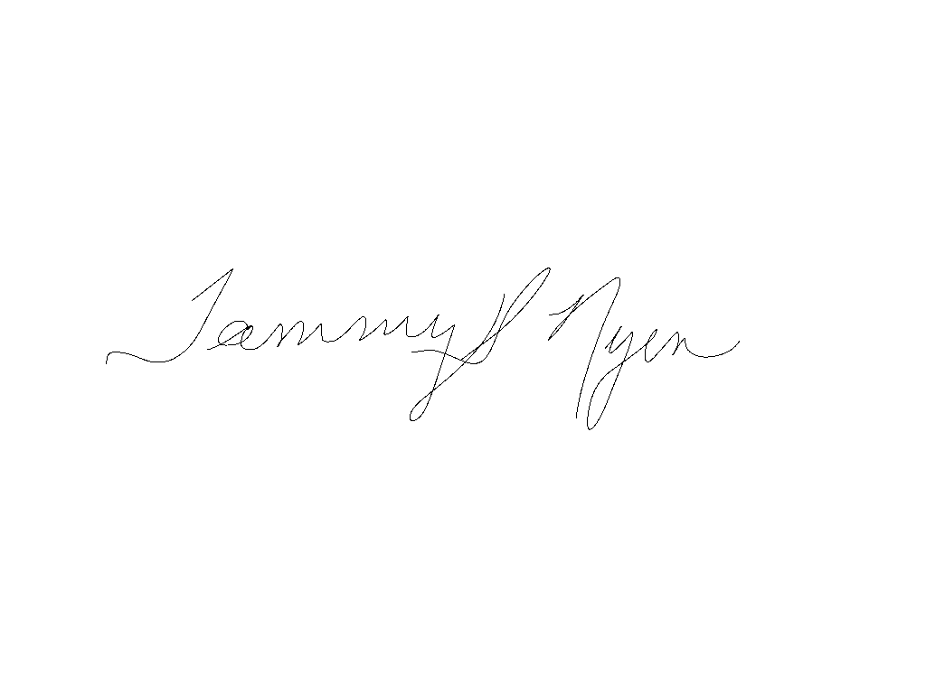

Tammy Nyen, Ed.D, Executive Director of Special Education

I agree that the student listed above should be receiving the services checked above.

|  |
| --- |
|  |
| **Physician/Other Licensed Practitioner ’s Signature NPI # Date** |
|  |
| **Name Printed** |

* Licensed practitioners operating within the scope of their practice, including Registered Nurses (RN), Occupational Therapists (OT), Physical Therapists (PT), Master of Social Work (MSW) and Speech-language Pathologists (SLP). **This prescription is good for one year from the start date of the IEP.**